
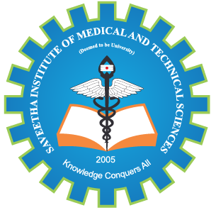
SIMATS ENGINEERING

Saveetha Institute of Medical and Technical Sciences
Chennai- 602105
March-2026
Student Name: R. KAVIYA Reg. No.:192524154
Course Code: CSA1713 Slot: C
Course Name: Artificial Intelligence
Course Faculty: Dr. Anandh Nagarajan
Project Title: AI-BASED STUDENT ELIGIBILITY, PROGRESS AND CAREER GUIDANCE SYSTEM

Module Photographs:
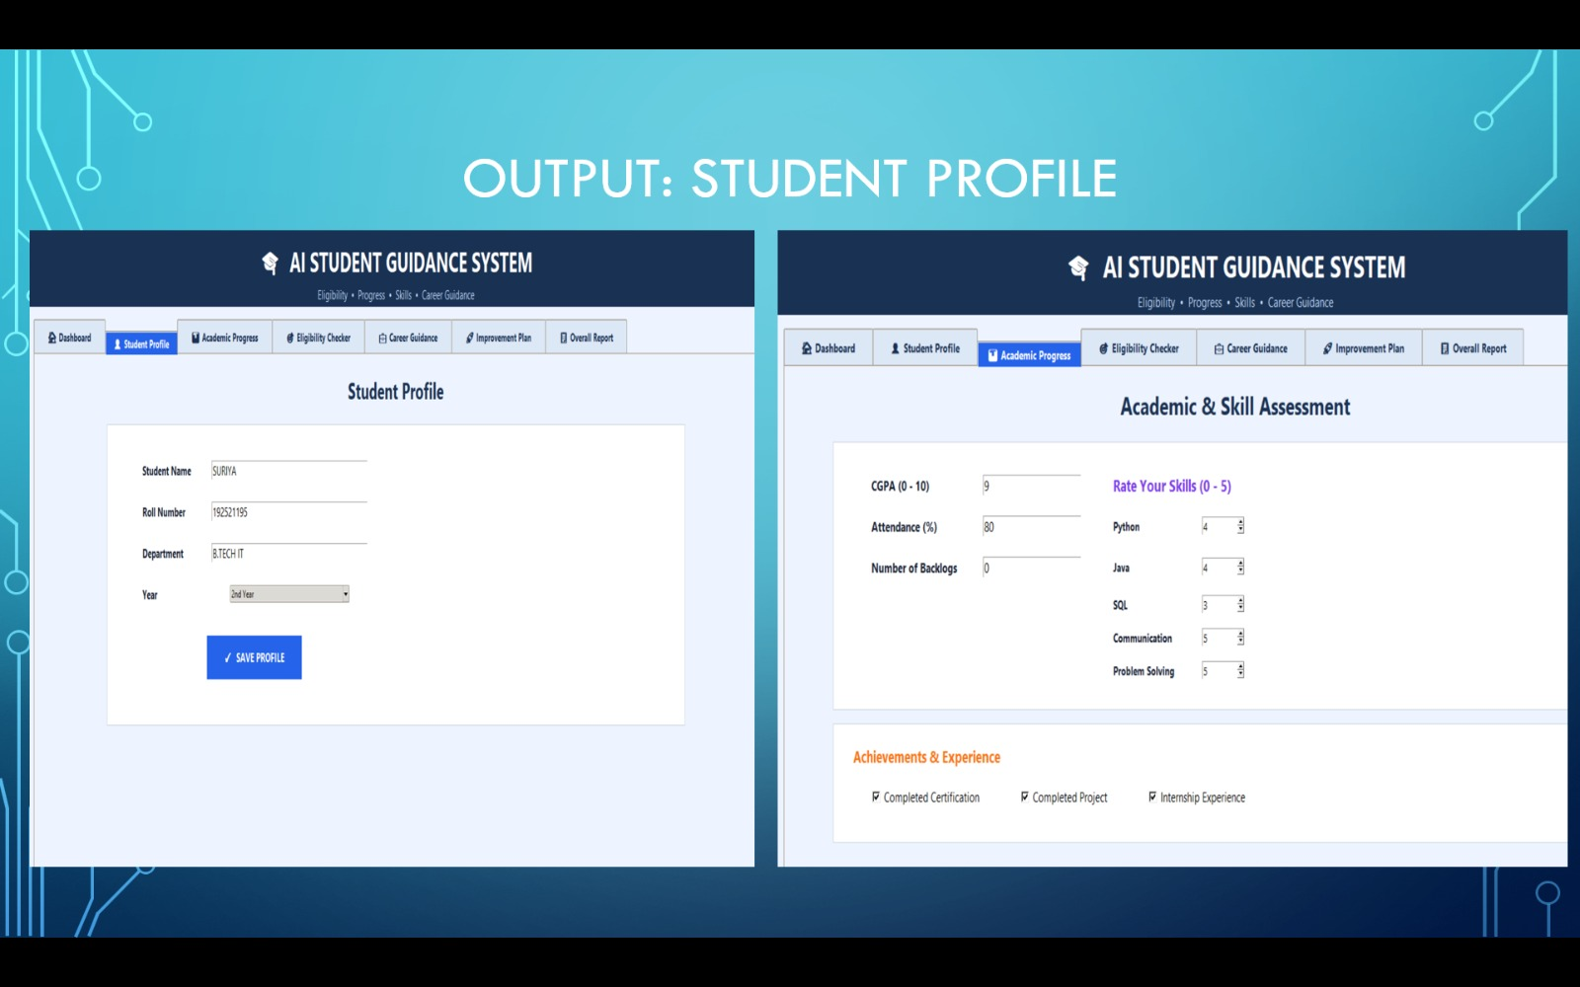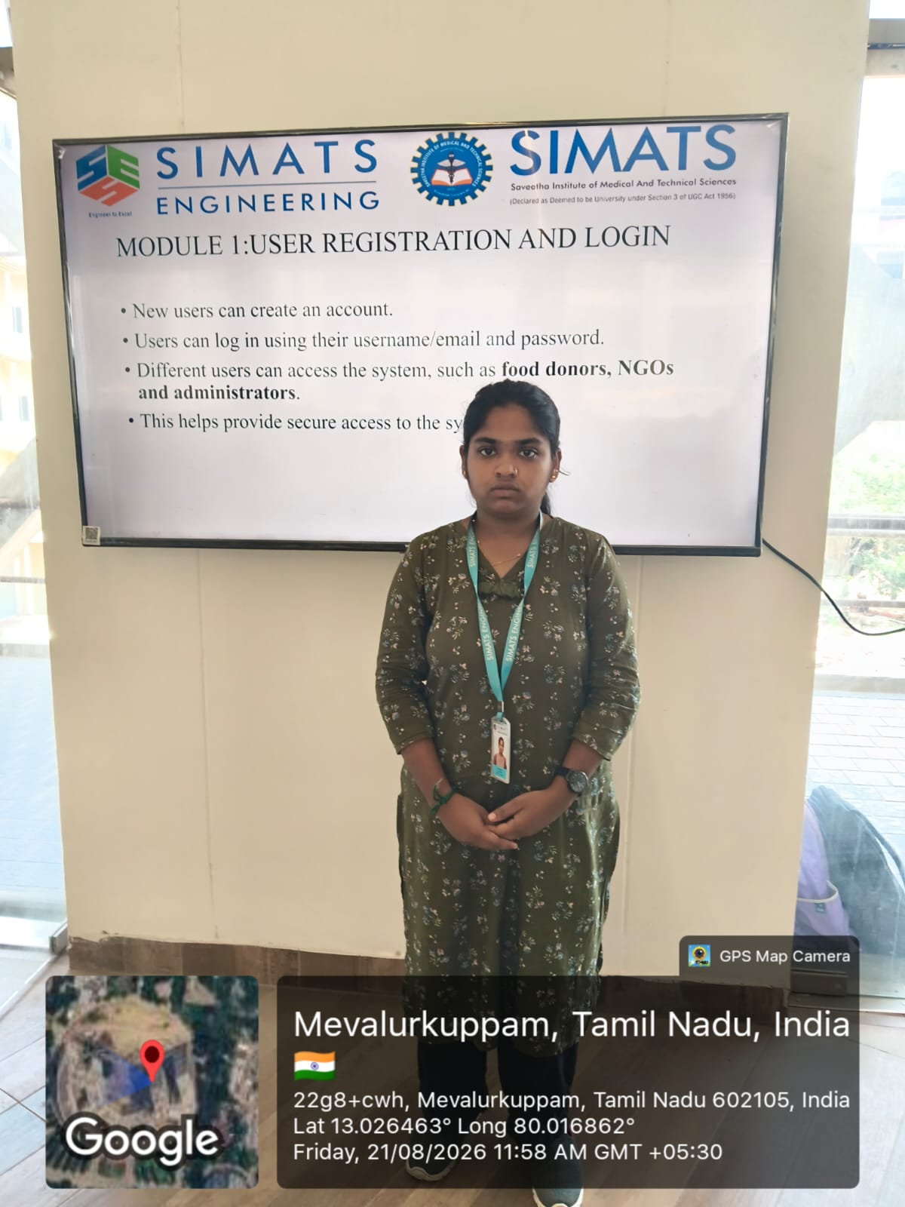
Project Description: The AI-Based Student Eligibility, Progress and Career Guidance System is designed to help students understand their academic and career readiness.
The system analyses academic performance, attendance, skills, certifications, projects and areas of interest to create a complete student profile. It checks the student's eligibility for placements, internships, jobs, higher studies and other opportunities based on their requirements. The system identifies the skills and qualifications that the student currently has and highlights the missing requirements.AI-based analysis is used to identify skill gaps and areas where the student needs improvement. It provides personalized career recommendations along with suitable skills, certifications and projects to improve career readiness.
Overall, the system helps students understand their current progress and plan their academic and career growth effectively.

Student Signature Guide signature

